**Project title** - Netflix Insights and Visualization

**Team members**- Gauri Gupta, Tanya Qader, Katie Nguyen, Anjali Sagar

**Project description/outline-** Studying movies and TV show trends across different countries and years.

**Research questions to answer:** -

What content is available in different countries?

Which genre is most watched?

Highest-rated movie in a particular year?

How many TV shows and movies are available for kids?

.

. (More to be added)

.

**Dataset to be used**- Netflix_titles.csv

**A rough breakdown of tasks –**

Scrum Master -

Extract-

Transform -

Data Visualization-

Question 1:

Findings:

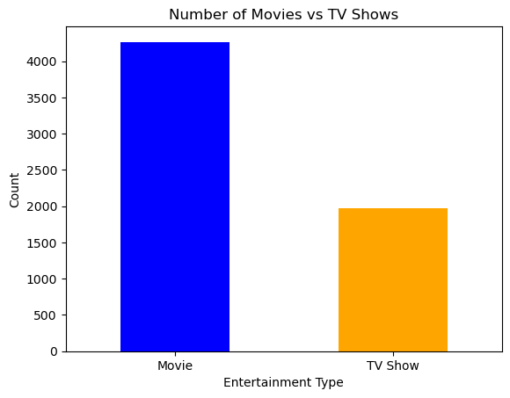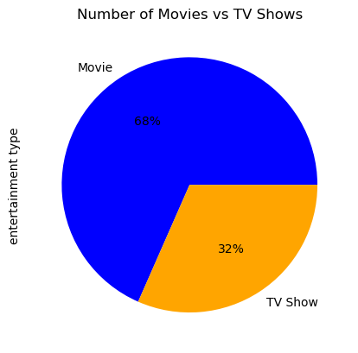

**1969**

**4265**